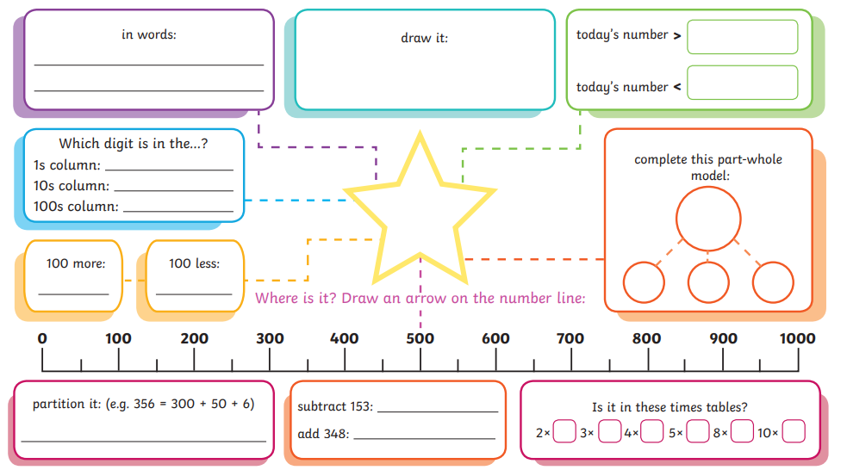

Choose a number between 200 and 999. Write it in the centre star and complete the activities around it!

