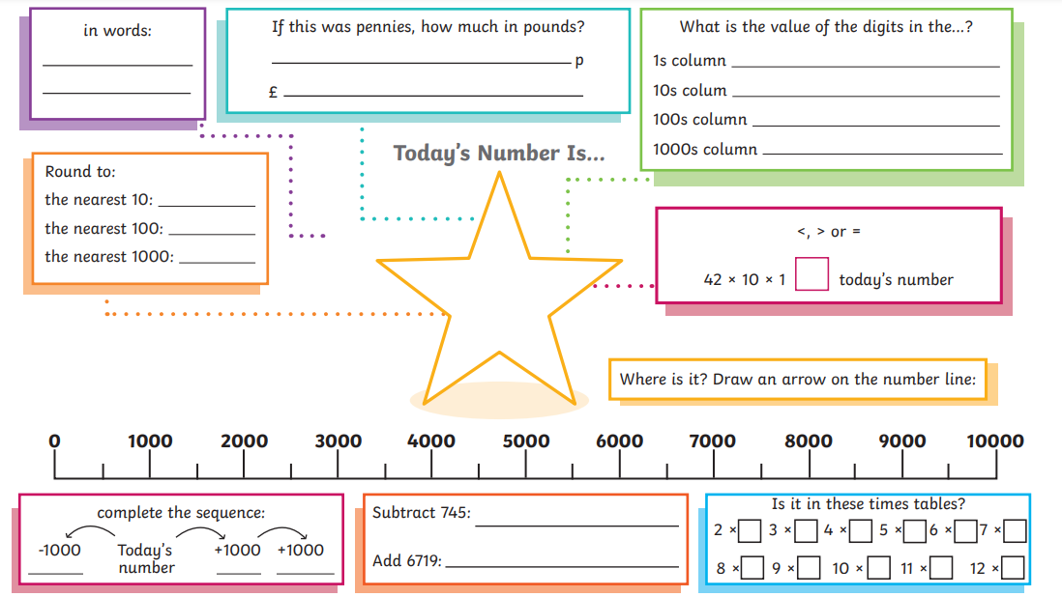

Choose a number between 1000 and 9999. Write it in the centre star and complete the activities around it!

