


November 2021

Online Safety Newsletter

Grand Theft Auto (GTA)



GTA is rated 18+ by PEGI (a couple of versions are rated 16+), this is largely because of bad language, violence, glamourisation of crime and the depiction of drugs. GTA is not suitable for those under this age.

What do I need to be aware of?
- Mature content
- In game chat
- In game spending – make sure your bank account details are not linked.

Call of Duty Mobile
There is also a mobile version of Call of Duty for Android and iOS devices. Find out more about this version here:
https://www.net-aware.org.uk/networks/call-of-duty-mobile/

It is important to talk to your child regularly about what they are playing online and make sure that they know that they should always talk to you or another trusted adult if they have any concerns.

What can we play instead?
You can use this database to search for games based on your child’s age:
https://www.taminggaming.com/cgi-bin/taminggaming.cgi

Squid Game – rated 15+
Have you heard of Squid Game? It’s one of Netflix’s latest releases about a group of people participating in a series of children’s games in the hope of winning a large cash prize. It has been rated 15 by the British Board of Film Classification (BBFC). The BBFC focus on helping you choose what is appropriate for your family to watch. You can find out why Squid Game has been rated 15 by visiting the BBFC: https://www.bbfc.co.uk/release/squid-game-q29sbgvjdglvbjpwwc01mzm3ndg.

Due to its current popularity, content from this show can be found on numerous other platforms such as YouTube, TikTok and Roblox, so your child may come across this show without even viewing it on Netflix. Content may range from trailers of the show or content that other people create such as memes, reenactments and games.

What can I do?
Talk
Chat to your child about age ratings and why this means certain programmes are not suitable for them to watch.

Individual Profiles
Set up child profiles on any streaming services to ensure your child is only viewing content appropriate to them.
Parental Controls
Set up appropriate parental controls on your broadband, devices and on individual apps.

Explore
Watch and explore things online together so you can see what your child is doing and how to support them.
Reporting
Make sure your child knows how to report and block on all platforms that they use.

More information:

It is important to talk to your child regularly about what they are watching and ensure that they know they should always tell you or another trusted adult if they do see anything upsetting. You can find out more about the type of inappropriate content your child might come across online, how to deal with it and links to further support here:
https://www.internetmatters.org/issues/inappropriate-content/learn-about-it/
Users of this guide do so at their own discretion. No liability is entered into. Current as of the date released 1.11.21.

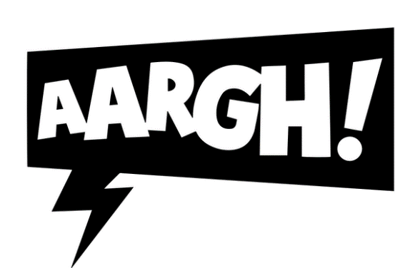

Your child’s online life

NSPCC launches new book

The NSPCC has launched a new children’s book called Pantosaurus and the Power of PANTS. This book will help families have simple conversations to help keep children safe from abuse. The book is available for £6.99 with all proceeds going to NSPCC. More information available here:

https://shop.nspcc.org.uk/products/pants

There is so much that we can do online nowadays including playing games, chatting with others, watching TV or sharing our videos/photographs. Being online can be great but it’s important that we set boundaries for our children to keep them safe whist they explore being online, develop their digital resilience and understanding of what to do if anything negative happens when online.

How to spot scams

Do you know how to spot a scam email/text/phone call? This article details what you should do if you receive a scam email and provides guidance on how to spot a scam email:

https://www.actionfraud.police.uk/scam-emails

It’s important to remember that your bank (or any other official source) should never ask you to supply personal information in an email. If you need to check, call them directly.

Further information
The National Cyber Security Centre provide guidance on how to deal with suspicious emails and text messages:
https://www.ncsc.gov.uk/guidance/suspicious-email-actions

So how can we help keep our children safe? We can start by checking age restrictions/ratings. It’s important that we follow these to ensure that what our children are doing or seeing online is appropriate for their age.

Where can I find age ratings?
- Films: The British Board of Film Classification (BBFC) rate films. This page includes a link to a ‘Parents' Guide to Age Ratings’: https://www.cbbfc.co.uk/resources/viewing-films-safely-online.
- Video games: PEGI provides age classifications for video games. PEGI considers the age suitability of a game, not the level of difficulty. It is important to note that PEGI do not take into consideration user generated content within games (such as on Roblox) and the chat facilities within games.
- Apps: Check the individual age ratings within the relevant app store. We also recommend that you download any apps and play them yourself to check their suitability.
- Social Media networks: All social media networks have a minimum age rating; they are all at least 13+.

What else can I do?
- Explain the importance of age ratings to your child.
- Go online together and let your child show you what they are accessing online.
- Set up parental controls on your broadband, devices, consoles and on any individual apps that your child is using. This will reduce the chances of them accessing anything unsuitable as well as viewing inappropriate content for example whilst on YouTube.
Anti-Bullying week: 15th – 19th Nov 2021

This year, the theme is One Kind Word. The Anti-Bullying Alliance have worked with Kidscape to develop a tool for parents and carers to help them support their children and bring Anti-Bullying Week to life. You can find out more here:
https://anti-bullyingalliance.org.uk/anti-bullying-week/parents-and-carers

- Chat to your child regularly about what they are doing online and as always, remind your child that if anything is worrying them about what they see online then they should tell you or another trusted adult.

What if my child has seen something inappropriate?
This is a useful article from Thinkuknow explaining what to do and who to contact if you have any concerns:
https://www.thinkuknow.co.uk/parents/articles/what-to-do-if-your-child-has-seen-something-inappropriate-online/

