How Do You Disable InPrivate in Internet Explorer?
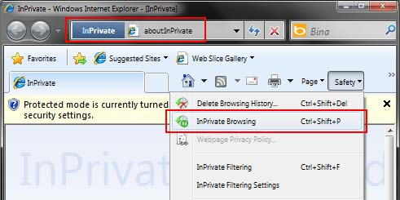
Internet Explorer, one of the most popular web browsers, has a private browsing feature called InPrivate.
Say you want to check your child's browsing history, but you can’t trace all the pages because they had InPrivate on while they were surfing the Internet?
You can disable InPrivate on Internet Explorer by following these steps.

Go to Start, then Run, type gpedit.msc and hit Enter.
You will see the Local Group Policy Editor.
Go to Computer Configuration -&gt; Administrative Templates -&gt; Windows Components -&gt; Internet Explorer -&gt; InPrivate
Double click on Turn off InPrivate Browsing.
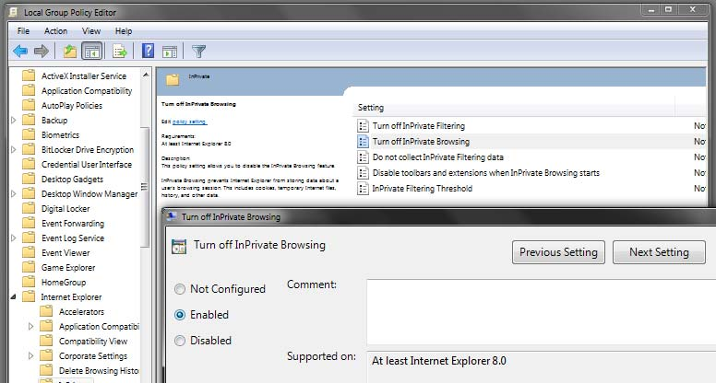
Click on Enabled and then on OK.
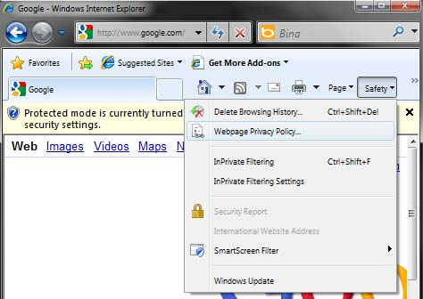

Information taken from
https://www.internetsafetyproject.org/wiki/how-disable-inprivate-internet-explorer

