
FFT Maths strategy

Mathematics plays a key role in a child’s development. It equips pupils with a uniquely powerful set of tools to understand and change the world. These tools include logical reasoning, problem solving skills, and the ability to become “out of the box” thinkers.

Mathematics is a creative discipline. It can stimulate moments of pleasure and wonder when a pupil solves a problem for the first time, discovers a more elegant solution to that problem, or suddenly sees hidden connections.

Mathematics is a core subject of the National Curriculum. It is given a high priority in all schools in The First Federation Trust. The most important reason for teaching mathematics to all children is that it can be used to provide them with a powerful means of communication to represent, to explain and to predict.

A teaching for mastery approach
All schools within the Trust have adopted a mastery approach to the teaching of Maths.
Mastering maths means pupils acquiring a deep, long-term, secure and adaptable understanding of the subject. The phrase ‘teaching for mastery’ describes the elements of classroom practice and school organisation that combine to give pupils the best chances of mastering maths. We believe that ’mastering’ a concept is a never-ending venture and that all pupils can continually deepen their understanding of a concept through being drawn to attend to it in another light.
Our Mastery approach is built upon the foundational beliefs that:
• All pupils are encouraged by the belief that by working hard at maths they can succeed.
• Pupils are taught through homogenised, whole-class interactive teaching, where the focus is on all pupils working together on the same lesson content at the same time.
• If a pupil fails to grasp a concept or procedure, this is identified quickly and early intervention ensures that the pupil is ready to move forward with the whole class in the next lesson.
• Lesson design identifies the new mathematics that is to be taught, the key points, the difficult points and a carefully sequenced journey through the learning. In a typical lesson, pupils sit facing the teacher and the teacher leads back and forth interaction, including questioning, short tasks, explanation, demonstration, and discussion. Lesson are planned to phase learning.
• Procedural fluency and conceptual understanding are developed in tandem because each supports the development of the other.
• It is recognised that practice is a vital part of learning, but the practice used is intelligent practice that both reinforces pupils’ procedural fluency and develops their conceptual understanding.
• Maths is a hierarchical subject and therefore significant time is spent developing deep knowledge of the key ideas that are needed to underpin future learning. The structure and connections within the mathematics are emphasised, so that pupils develop deep learning that can be sustained.
• Rigorous formative assessment is used within lessons to ensure that all children are keeping up with the content being taught. Prior to new concepts being taught, pre-requisite assessments are put into place to ensure that all children have the pre-requisite knowledge required in order to be able to access the new concept.
• Key facts such as multiplication tables and addition facts within 10 are learnt to automaticity to avoid cognitive overload in the working memory and enable pupils to focus on new concepts. The FFT have established a set of Non-negotiables in Maths which identify key learning that needs to be taught and secured by each child, by the end of each year group (See FFT Non-negotiable document). This includes a focus on key numbers facts.

The learning of mathematics is a never-ending journey. Once the start point has been established, there is no end-point. Our Mastery curriculum supports children to become “more expert” at the concepts they are taught. Crucial to our mastery approach is the notion that children recognise there is always more to learn about a concept.

In order for our pupils to develop a deepened understanding for mathematics, pupils will be required to become fluent with the fundamentals of mathematics, reason mathematically and solve problems (National Curriculum, 2014).

Becoming fluent
According to McCourt, 2019, fluency can be described as ‘the point at which someone no longer needs to give attention’. In order for this to happen, pupils need to commit their learning to their long-term memory, freeing up the working memory and in turn reducing cognitive load. Russell, 2000, went on to define fluency as a pupil’s efficiency, accuracy and flexibility towards a calculation. Pupils should be able to solve problems correctly with a variety of strategies, recognising which strategy would solve the problem the quickest. Fluency is more than rote-memorisation of independent facts.

Reasoning Mathematically
If we define ‘understanding’ as ‘the reasons why the connections are true’, we therefore expect children to be able to reason mathematically in order to deepen their understanding of mathematical concepts that are taught. In order to become fluent, children must be able to reason mathematically. Opportunities to reason could include: describing, explaining, convincing, justifying and proving.

Solving Problems
Problem solving cannot be directly taught however we can support children to become better problem solvers through developing deep understanding of maths, in particular making connections; developing logical reasoning – particularly through procedural variation; developing knowledge of mathematical structures through conceptual variation as well as developing analytical skills through specifically chosen question types.

Five Big Ideas in Teaching for Mastery
A central component in The First Federation Trust’s teaching for mastery approach is linked to the NCETM work on Five Big Ideas, drawn from research evidence. This is the diagram used to help bind these ideas together.
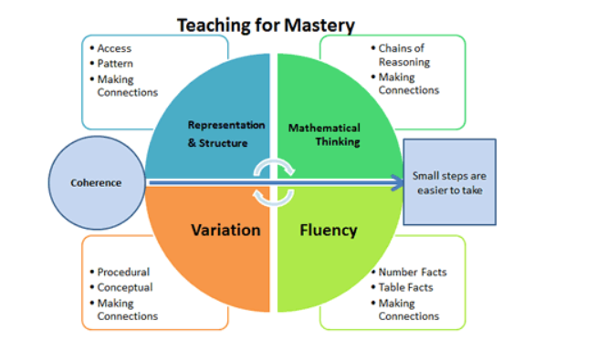
Coherence
Lessons are broken down into small connected steps that gradually unfold the concept, providing access for all children and leading to a generalisation of the concept and the ability to apply the concept to a range of contexts.
Representation and Structure
Representations used in lessons expose the mathematical structure being taught, the aim being that students can do the maths without recourse to the representation.
Mathematical Thinking
If taught ideas are to be understood deeply, they must not merely be passively received but must be worked on by the student: thought about, reasoned with and discussed with others.
Fluency
Quick and efficient recall of facts and procedures and the flexibility to move between different contexts and representations of mathematics.
Variation
Variation is twofold. It is firstly about how the teacher represents the concept being taught, often in more than one way, to draw attention to critical aspects, and to develop deep and holistic understanding. It is also about the sequencing of the episodes, activities and exercises used within a lesson and follow up practice, paying attention to what is kept the same and what changes, to connect the mathematics and draw attention to mathematical relationships and structure.

What are our aims in adopting a teaching for mastery approach?
- Teachers will access professional learning opportunities and training to develop their subject knowledge. We want teachers to appreciate the mastery approach as being a deep understanding of the structure of number and the fundamental concepts in mathematics, and how they are connected. By developing the subject matter knowledge of teachers, we can then apply this to develop teacher’s pedagogical content knowledge. However, it is imperative that these are developed in tandem; one without the other will not yield effective teaching (Ball, 2000). This coherent understanding allows teachers to break down concepts into a series of smaller steps, so they can be made accessible to all children. Teachers understand how mathematical fluency and reasoning develop in unison. Teachers are using this knowledge to shape schools’ development of the curriculum to ensure that children are developing factual knowledge, such as multiplication tables and a deep understanding of mathematical concepts. There is also a focus on the development of precise language. Subject knowledge is developed through a range of professional development opportunities which are provided for all teaching staff, teaching assistants and the individual schools’ Maths Subject Leaders. Representation and calculation PowerPoints provided by the FFT Maths team provide teachers with a clear toolkit for sequences of learning which identify key structures, models and stem sentences that are used to plan and teach Maths concepts.
- Teachers adopt strategies to ensure all children access the whole curriculum. Teachers do not let lower-attaining children experience a narrower range of mathematics. All children are expected to achieve key learning points, working independently through the same sequence of work. Using Mark McCourt’s Teaching for Mastery model, teachers understand the importance of assessment in order to keep the group homogenised, and as a result, allowing all children to keep up with the curriculum.
- Teachers and children emphasise number facts, precise mathematical language and full sentences. Teachers use stem sentences to develop children’s language and reasoning through oral contributions. Teachers have a developing awareness of the precision of their vocabulary choices, particularly when aligning these with the correct image to support the concept.
- Lessons will develop children’s fluency and reasoning together. Lessons focus on children’s understanding of the structure of number, mathematical laws and focusing on the method as well as the answer. Teachers use concrete and pictorial representations throughout the school, not just in specific years or key stages. Once structural understanding has been achieved, Teachers continue to guide pupils towards efficient strategies, comparing them with those of their peers.
- Teachers plan maths lessons by mapping key mathematical concepts in a topic, then breaking them down into small steps. The Trust have provided a maths spine to all staff which maps out small steps learning under key mathematical concepts. This acts as a guide for teachers to work from, adapting their journeys as they see necessary.
- Teachers are adopting and adapting teaching for mastery principles in mixed-age classes.
- Schools’ internal structures have changed through a considered, gradual approach, based on the principle that all children should access the whole maths curriculum. The First Federation Trust have acknowledged they cannot do everything at once, so are adopting mastery in one year-group at a time (e.g. starting in Year 1 2019). We are using the NCETM spines to support teacher support knowledge, exposure to appropriate representations and the development of mathematical language.
- Schools are ensuring their systems support the principle of ‘keep up, not catch up’. Adaptations to feedback and marking policies include utilising immediate verbal feedback and in-class marking. Both these adaptations have reduced teacher workload and help to identify children who require rapid intervention.
- Schools identify the development of mathematical vocabulary and language as having an impact on children’s progress. The FFT recognise how the use of language can act as a barrier for children in truly understanding the meaning a concept. With this in mind, teachers ensure children have the means to represent their mathematical reasoning verbally and accurately whilst also being able to articulate mathematical statements, including generalisations.

Key principles of effective Maths teaching for EYFS and Key stage 1.
- Practitioners understanding of how children learn maths.
In order for children to learn in Maths, children need to engage in appropriate, challenging activities within a culture which supports their curiosity, thinking and problem solving. The rate of mathematical development is not solely reliant on maths knowledge and skills but also on:
- Executive functions such as working memory, self-regulation and metacognition skills
- Language skills
- Motor skills (to support counting objects and writing numerals)
- Children’s prior experiences with maths materials and activities
- Children’s interest, engagement and attitudes towards maths.
Teaching of mathematics should be informed by knowledge of developmental progressions.
Research has suggested possible paths children may follow in developing understanding of a mathematical topic. Developmental progressions are descriptions of the typical path that children tend to follow in developing an understanding of a mathematical topic. These progressions are spiral to convey that whilst there is some ordering in which these skills may emerge, development does not take place in clearly defined linear steps. Children may develop several skills in parallel and individuals will move through in different orders. As a Trust we have looked at the NCETM materials for the teaching of Early Maths, combining this with the work of the Erickson Early Math Institute; these focus on 6 key areas of maths. These collectively provide a platform for everything children will encounter as they progress through their maths learning at primary school, and beyond:
- Cardinality and Counting: understanding that the cardinal value of a number refers to the quantity, or ‘howmanyness’ of things it represents.
- Comparison: understanding that comparing numbers involves knowing which numbers are worth more or less than each other
- Composition: understanding that one number can be made up from (composed from) two or more smaller numbers
- Pattern: looking for and finding patterns helps children notice and understand mathematical relationships
- Shape and Space: understanding what happens when shapes move, or combine with other shapes, helps develop wider mathematical thinking
- Measures: comparing different aspects such as length, weight and volume, as a preliminary to using units to compare later.

The developmental progressions form our Maths curriculum for the EYFS (See FFT Becoming a Mathematician document). Teachers will use these developmental progressions to identify what children need to learn to progress, make judgements about the range of experiences that children may benefit from to develop a full understanding of maths topics, determine the pre-requisites for a particular skill, assess a child’s level of understanding and intervene at the appropriate level of challenge building on what children already know.
See Appendix A which outlines how teachers can develop early number sense with children. This appendix has been informed by the EEF guidance Improving Maths in the Early Years and Key Stage 1.

Key principles of effective Maths teaching for Key stage 2.
- Teachers use assessment to build on pupils’ existing knowledge and understanding
Assessment provides teachers with up to date information about the specifics of what pupils do and do not know. This information is used to adapt teaching to build on pupils’ existing knowledge, address any gaps and identifying the next steps needed in order for a child to progress.
Where teachers have a secure understanding of misconceptions in maths, they are able to predict difficulties that learners may have in advance of teaching. Lessons are then planned to address potential misconceptions.

- Use manipulatives and representations
Manipulatives, when used purposefully and appropriately, can support pupils to engage with mathematical ideas. Teachers need to have a clear rationale for using a particular manipulative so that it reveals the desired mathematical structures.
Representations refers to a particular form in which maths is presented e.g 2 fractions represented on a number line or an additive calculation represented in a bar model. Research supports the use of representations in developing problem solving strategies.
There are a number of consistent models that should be easily recognised across Key stages. These include: part-whole models (bar and cherry) tens frames and number lines. (See Appendix B).

- Teaching should provide opportunities for children to develop problem solving strategies.
Problem solving means situations in which pupils do not have a readily available method that they can use, a solution needs to be worked out. It is not a problem if it has already been seen before.
When developing problem solving skills, teachers should consider the following:
Encourage pupils to use visual representations;
Use worked examples and backward fading to enable pupils to analyse the use of different strategies (A worked example is a step-by-step demonstration of how to perform a task or solve a problem. With backward fading, this is where you show a fully worked out example. Then the next problem is worked out except for the last step etc etc.) ;
Solve a range of problems for which strategies can be drawn upon when faced with new problems.
Pupils should monitor, reflect on and communicate their reasoning and choice of strategy, ultimately looking to develop efficiency in their own strategy, as well as curiosity across the strategies of others.

- Children should develop a rich network of mathematical knowledge
Teaching should emphasize the many connections between different mathematical facts, procedures and concepts.
Children should develop fluent recall of number facts. The First Federation Trust have adopted a set of non-negotiable facts that need to be retrieved quickly by children by the end of different year groups (See FFT Non-negotiables in Maths). These should be explicitly taught, developing both conceptual and procedural understanding in tandem.
- Pupils should understand procedures so that they can apply them effectively
- Pupils should choose between mathematical strategies. By teaching a range of mental and written methods, children will be able to consider when different methods are appropriate for efficiency.
- Build on pupils’ informal understanding of multiplicative reasoning to introduce procedures.
- Teach pupils that fractions and decimals extend the number system beyond whole numbers
- Teach pupils to recognise and use mathematical structure (See Appendix B for some examples)

- Develop pupils’ independence and motivation
Teachers should encourage pupils to take responsibility for, and play an active role, in their own learning. Pupils need to develop metacognition (the ability to independently plan, monitor and evaluate their thinking and learning), and motivation towards learning maths.
All staff will encourage and model motivation, confidence and enjoyment in maths for all children. In addition to this, accurate assessment of where a pupil is on their mathematical journey will result in appropriately pitched learning and ultimately motivation through success.
Teachers will engage with parents to encourage their children to value maths, and develop confidence in the subject.

Appendix A
Developing early number sense.
We want all of our children to develop a secure understanding of number, counting and place value. Our EYFS and KS1 teachers, use the Numberblocks programmes (BBC) and resources to support their teaching. These materials are designed to help Early Years practitioners to draw out and build on the maths embedded in the stories. Furthermore, teacher are encouraged to:
- Mathematise the world around us. Help children engage in the mathematics all around them, creating meaningful experiences and avoiding counting for counting’s sake.
- Teachers dedicate time for children to learn maths and integrate maths throughout the day.
In the Early Years and Key Stage 1, there are opportunities throughout the day to learn about maths through the environment and routines, as well as in dedicated teaching time. Maths can be explored through different contexts including books, puzzles, songs, rhymes and games.
Throughout the day, children are also exposed to mathematical language, both formal and informal. Teachers will create opportunities for extended discussions of mathematical ideas in order to extend their thinking.
Features of such approaches include:
- The use of open ended questions such as ‘How did you…? Why does this….?’
- Asking children to elaborate: I really want to know more about this…
- Recapping: So you think that….
- Clarifying ideas: So you think we should….

- Use manipulatives and representations to develop understanding
Developing a secure understanding of early mathematical concepts takes time but this is a worthwhile investment for future mathematical learning. Children across the 3-7 age range need time (structured and unstructured) to explore manipulatives, to represent problems in their own ways, and to communicate their mathematical thinking (perhaps through drawings, jottings, manipulatives or dialogue). As children are engaged in sense making within mathematics, meaningful contexts – such as carefully selected games, stories and daily routines – are important for building mathematical understanding. Of equal importance is ensuring that they make the maths more than just the manipulatives, allowing them to make connections between the symbols, pictures and language.

- Teaching recognises receptive learning and will build on what children already know.
Teachers carefully assess what children know in order to identify the appropriate areas to extend learning. Whilst children are very young, language may be a barrier to explaining their mathematical thinking and as a result, teachers must be alert to non-verbal indications of mathematical understanding. Information gained is used to provide feedback, intervene and plan future learning activities.

- Get mathematics into children’s eyes, ears, hands and feet.
Multimodal learning, engaging multiple sensory and action systems of the learner deepens learning. When new ideas are presented in different ways, the learner makes more connections between new ideas and familiar concepts.

- High quality targeted support helps all children learn maths
Sometimes children will need targeted small group or one to one support to make progress in maths. Within our schools, targeted support is provided by:
- Experienced staff
- Training and support for staff
- Brief and regular sessions with children
- Connections are made with current learning, during targeted activities.

Appendix B:
Templates of structural models:
First Then Now
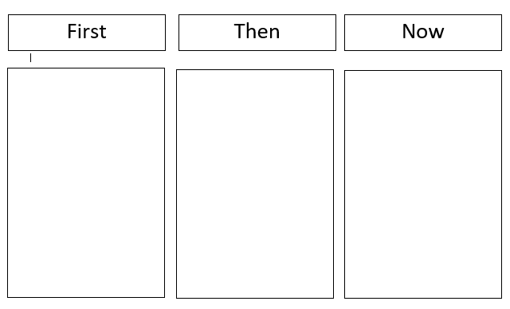
Bar Model
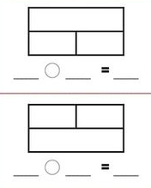

Five and Tens frames
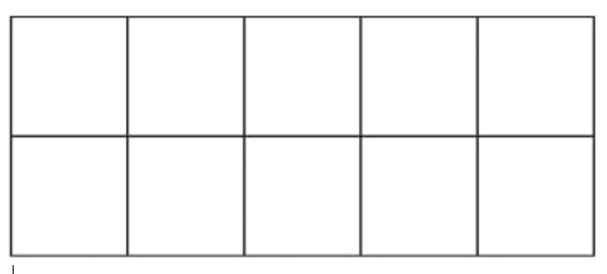

Part whole
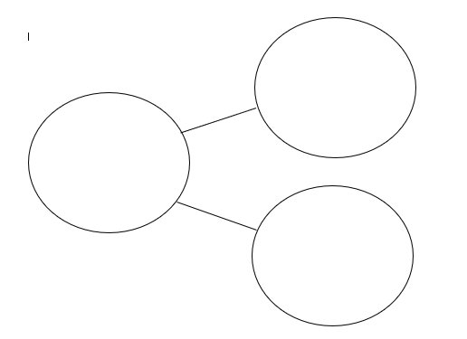

References
McCourt, M, (2019) Teaching for Mastery.
Russell, Susan Jo. (May, 2000). Developing Computational Fluency with Whole Numbers in the Elementary Grades. In Ferrucci, Beverly J. and Heid, M. Kathleen (eds). Millenium Focus Issue: Perspectives on Principles and Standards. The New England Math Journal. Volume XXXII, Number 2. Keene, NH: Association of Teachers of Mathematics in New England. Pages 40-54.
EEF, 2020, Improving Mathematics in the Early Years and Key Stage 1, Guidance report
EEF, 2019, Improving Mathematics in Key Stage 2 and 3.
Ball, DL (2008). Bridging Practice: Intertwining content and pedagogy in teaching and learning to teach. Journal of Teacher Education, 51 (3), 241-247.
The Early Math Collaborative (2013). Big Ideas of Early Mathematics: What teachers of young children need to know.
NCETM (2019). Five Big Ideas of Teaching for Mastery. https://www.ncetm.org.uk/resources/50042
NCETM (2019) The Essence of Maths Teaching for Mastery. https://www.ncetm.org.uk/files/37086535/The+Essence+of+Maths+Teaching+for+Mastery+june+2016.pdf

